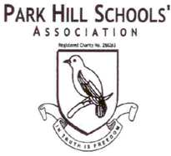

Christmas Card Artwork & BAGS2SCHOOL

Thank you to everyone who took part in these events. We raised £91 from Christmas artwork products and £248 from all the BAG2SCHOOL donations! Brilliant!

**SAVE THE DATE!**

Our summer fair will be held on Saturday 2nd July 2022

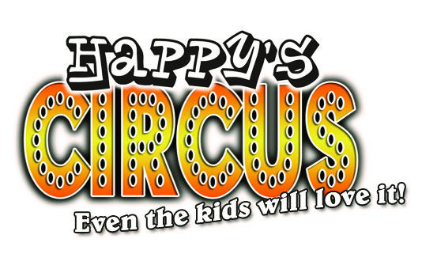

Exciting news!!!

Happy’s Circus is coming to school on Thursday 12th May.

Tickets will be going on sale at the end of February and will cost £10 each. (Under 2s go free) Book your tickets here

[https://www.pta-events.co.uk/parkhillschools](https://www.pta-events.co.uk/parkhillschools/)



# Can you help?

We are always looking for help and support for our different fundraising events. If you can help in any way please let us know!

[phsa.croydon@gmail.com](mailto:phsa.croydon@gmail.com)

Where does your money go?

Each year the money raised by the PHSA is shared between Park Hill Infant and Park Hill Junior Schools. This year the juniors are looking to invest in their Reading Shed by improving and insulating it, making it a comfortable and warm area for the children to read and enjoy. Such a great investment to support our childrens learning experience!



Amazon Smile 

Don’t forget to add us to your Amazon Smile account! Raise important funds for the school while you shop! We raised £80 between July and December!

# Twitter

@park_schools [](https://www.google.co.uk/url?sa=i&rct=j&q=&esrc=s&source=images&cd=&ved=2ahUKEwjM1MO858DjAhVFDWMBHUNiAKMQjRx6BAgBEAU&url=https://en-gb.facebook.com/&psig=AOvVaw2e4VK8ivbXsyeyZhUtiNe8&ust=1563619701431682) Park Hill Schools’ Association

Christmas Raffle

Thank you all for your support for the Christmas raffle! We had an amazing response from our school community and made over £1000. Congratulations to all of our winners!

Park Hill Schools’ Association