Big Ideas
 | Thread | Description
Biology   | Animals, including humans | Pupils learn to identify and name common animals (fish, amphibians, reptiles, birds, and mammals), including their diets (carnivores, herbivores, omnivores), structures, and life cycles. They study the human body—its basic parts, senses, and functions—and understand that animals and humans need food, water, and air to survive.  They explore nutrition, the role of skeletons and muscles, the digestive and circulatory systems, types of teeth, and how nutrients and water are transported. Students also learn about food chains, human development from birth to old age, and how exercise, diet, hygiene, drugs, and lifestyle affect body function.
 | Living things and their habitats | Pupils learn to distinguish between living, dead, and non-living things and explore how living things depend on their habitats to meet their needs. They identify and classify plants and animals and study simple food chains. Learners group living things using classification keys, explore how environments change, and examine life cycles and reproduction in animals and plants. They also learn how and why living things are classified into broad groups based on shared characteristics.
 | Plants | Pupils learn how seeds and bulbs grow into mature plants. They explore what plants need to live and grow, the functions of different parts (roots, stems, leaves, flowers), how water is transported, and the role of flowers in reproduction, including pollination, seed formation, and dispersal.
 | Evolution & Inheritance | Pupils learn that living things change over time, that fossils show what lived on Earth millions of years ago, that offspring resemble but differ from their parents, and that animals and plants adapt to their environments—adaptations which can lead to evolution.
Chemistry  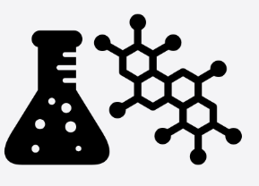 | Materials | Pupils learn to identify, name, and describe everyday materials and their physical properties, comparing their suitability for different uses. They explore how materials can change shape and investigate properties such as hardness, solubility, transparency, and conductivity. Learners study how materials dissolve, mix, and change state, how mixtures can be separated, and the difference between reversible and irreversible changes, including those that form new materials.
 | Rocks | Pupils learn to compare and classify rocks based on their appearance and properties, understand how fossils form in rocks, and recognize that soils are composed of rocks and organic matter.
 | States of matter | Pupils learn to classify materials as solids, liquids, or gases, observe how materials change state with heating or cooling, and understand evaporation and condensation in the water cycle, including the effect of temperature on evaporation rate.
Physics   | Electricity | Pupils learn to identify electrical appliances, construct simple series circuits, and understand the roles of cells, wires, bulbs, switches, and buzzers. They explore how circuit completeness, switches, and conductors/insulators affect whether components work, investigate how the number and voltage of cells influence brightness and volume, compare component performance, and represent circuits using standard symbols.
 | Earth & Space | Pupils learn to observe and describe seasonal changes, weather patterns, and variations in day length. They study the movements of the Earth, moon, and other planets, understand their roughly spherical shapes, and use Earth’s rotation to explain day, night, and the sun’s apparent movement across the sky.
 | Forces & Magnets | Pupils learn about forces and motion, including how objects move on different surfaces, the effects of contact and magnetic forces, and how magnets attract or repel. They explore gravity, air and water resistance, friction, and how simple mechanisms like levers, pulleys, and gears can amplify force.
 | Sound | Pupils learn how sounds are produced by vibrations, how they travel through a medium to the ear, and how pitch and volume relate to the characteristics and strength of vibrations. They also observe that sounds become fainter with increasing distance from the source.
 | Light | Pupils learn that light is needed to see, that darkness is the absence of light, and that light can be reflected. They study how shadows form and change size, understand that light travels in straight lines, and explain vision and shadow formation based on the path of light.

Disciplinary Knowledge - Working Scientifically
  Asking questions | Ask questions that can be answered using a scientific enquiry
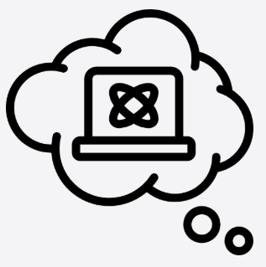  Making predictions | Using prior knowledge to suggest what will happen
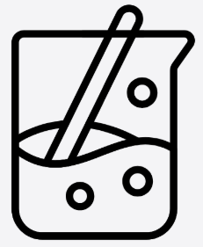  Setting up tests | Deciding on a method and equipment to use to carry out the enquiry
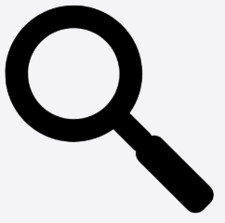  Observing and measuring | Using senses and measuring equipment to make observations about the enquiry
  Recording data | Using tables, drawings and other means to note observations and measurements
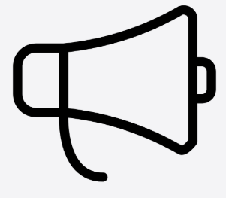  Interpreting and communicating results | Using information from the data to say what you found out
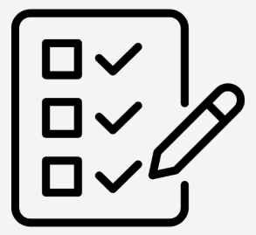  Evaluating | Reflecting on the success of the enquiry approach and identifying further questions for enquiry

Enquiry Type | Description
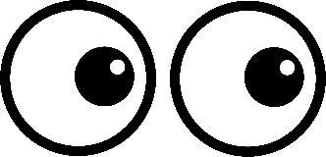  Observing changes over time | Children observe, measure and record how something changes across a period which could range from minutes to months
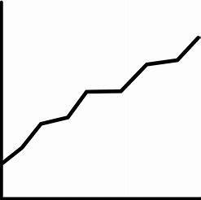  Pattern Seeking | Children collect, observe and measure data to find a relationship or link between two factors.  This will be used when children cannot control all the conditions
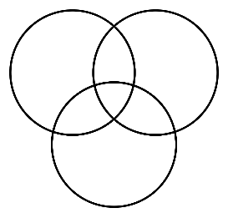  Identifying and classifying | Identifying means children will figure out and name a specific thing from a group.  Classifying means children will look at similarities and differences to group items into categories.
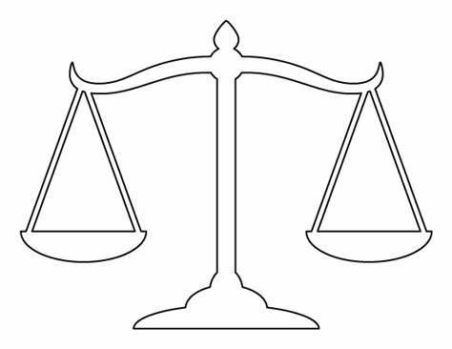  Comparative and fair testing | Comparative testing means children will compare different groups, objects and materials to see how they perform.  Fair testing is where children change only one thing (variable) and keep all other conditions the same
  Research | Children will find out information using books, trusted websites or videos when practical experiments are not possible.

 | Autumn |  | Spring |  | Summer
Year 3 | Animals Including Humans | Rocks | Light | Plants | Forces and Magnets
Year 4 | Sound | Electricity | Living things and their habitats | Animals including humans | States of Matter
Year 5 | Properties and Changes of Materials |  | Earth and Space |  | Forces | Living things and their habitats  Animals including humans
Year 6 | Animals including humans |  | Evolution and Inheritance | Living things and their habitats | Light | Electricity

Disciplinary Knowledge (Working Scientifically) Progression
 | Year 3 | Year 4 | Year 5 | Year 6
Asking Questions | Can I ask questions about the world around me?  Can I answer questions posed by the teacher, independently or with support?  Can I recognise when to use secondary sources to answer questions that cannot be answered in practical science?  Can I carry out research using a small range of secondary sources? | Can I decide how to gather evidence to answer questions?  Can I raise questions to help identify and group?  Can I write a range of questions using my own scientific knowledge?  Can I recognise when secondary sources can be used to answer questions and can I select appropriate information from sources? | Can I ask relevant questions?  Can I use scientific experiences to explore ideas and raise different questions?  Can I create further questions from enquiries?  Can I independently use secondary sources to find relevant facts about a topic? | Can I ask relevant questions based on my scientific knowledge and experiences?  Can I raise questions to further prove a scientific enquiry?  Can I independently use secondary sources to find relevant facts about a topic?
Making Predictions | Can I make predictions from questions posed? | Can I use evidence and subject knowledge to make predictions? | Can I develop predictions using my own ideas and subject knowledge  Can I gather evidence through practical science to support predictions? | Can I develop predictions using my own ideas and subject knowledge  Can I use evidence to support predictions?  Can I use test results to make further predictions?
Setting up tests | Can I recognise different forms of scientific enquiry?  Can I set up practical enquiries with support?  Can I follow basic instructions scaffolded by the teacher to conduct an investigation? | Can I follow a plan to carry out observations and tests?  Can I select from a range of resources to gather evidence?  Can I begin to understand that there are different variables? | Can I identify the type of enquiry needed to answer a question?  Can I plan the scientific enquiry with more independence?  Can I identify variables, including dependent, independent and controlled? | Can I choose a suitable method to carry out the investigation?  Can I identify a range of factors which may affect their investigation?  Can I identify variables, including dependent, independent and controlled?  Can I ensure variables are controlled?
Observing and Measuring | Can I use a range of equipment to collect data/results with support?  Can I make observations and record these to answer a question? | Can I use a range of equipment to collect accurate results/data?  Can I make systematic and careful observations?  Can I use observations to ask questions and group objects?  Can I observe closely and describe processes such as changes of state? | Can I make my own decisions about what to observe based on the question being asked?  Can I record my observations clearly?  Can I take repeated measurements where appropriate?  Can I use equipment making sure I have precise results? | Can I use my observations to answer questions based on evidence?  Can I choose a suitable way to record my observations?  Can I use a range of scientific equipment, with increasing accuracy and precision?  Can I take repeat readings where appropriate?
Recording Data | Can I record findings using scientific language, drawings and labelled diagrams?  Can I complete a table of results (where the template has been given)?  Can I begin to record my results in a graph (with support)? | Can I record findings using careful observational drawings and labelled diagrams?  Can I create my own tables with headings?  Can I record my results in a graph/chart with less support? | Can I present my results in a variety of ways?  Can I produce my own results table?  Can I record my results in a graph or chart with more independence? | Can I present my data in a range of ways to help answer the question?  Can I record my results with scientific diagrams and labels?  Can I independently present my results in an appropriate graph or chart?
Interpreting and Communicating Results | Can I find patterns in the results/data?  Can I draw conclusions based on observations and data?  Can I use data and findings to answer questions? | Can I draw simple conclusions from the results to answer questions and support predictions?  Can I sport anomalies?  Can I adjust my opinions based on my results? | Can I interpret the data to generate simple statements?  Can I use my results to draw conclusions?  Can I begin to give reasons as to why there may be anomalies? | Can I use data to refute or support ideas?  Can I use my results to make further predictions?  Can I spot anomalies and give reasons for them?
Evaluating | Can I suggest improvements? | Can I suggest improvements? | Can I evaluate different aspects of my enquiry such as equipment and accuracy of measurements? | Can I evaluate my choice of method, the control of variables, the precision and accuracy of measurements and the credibility of secondary sources?  Can I use scientific language and evaluate how my enquiry has answered the question?

Progression in Substantive Knowledge

 |  | Year 3 | Year 4 | Year 5 | Year 6
BIOLOGY | Plants  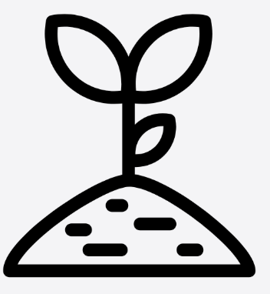 | Can I identify & describe the functions of different parts of the flowering plants: roots, stem/trunk, leaves & flowers?  Can I explore the requirements of plants for life & growth (air, light, water, nutrients from soil, & room to grow) & how they vary from plant to plant?  Can I investigate the way in which water is transported within plants?  Can I explore the part that flowers play in the life cycle of flowering plants, including pollination, seed formation & seed dispersal?
BIOLOGY | Animals including humans  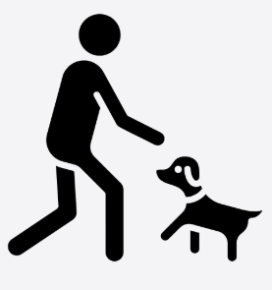 | Can I identify that animals, including humans, need the right types & amounts of nutrition, & that they cannot make their own food: they get nutrition from what they eat?  Can I identify that humans & some other animals have skeletons & muscles for support, protection & movement? | Can I describe the simple functions of the basic parts of the digestive system in humans?  Can identify the different types of teeth in humans & their simple functions?  Can I construct & interpret a variety of food chains, identifying producers, predators & prey? | Can I describe the changes as humans develop to old age? | Can I identify & name the main parts of the human circulatory system, & describe the functions of the heart, blood vessels & blood?  Can I recognise the impact of diet, exercise, drugs & lifestyle on the way their bodies function?  Can I describe the ways in which nutrients & water are transported within animals, including humans?
BIOLOGY | Living things and their habitats  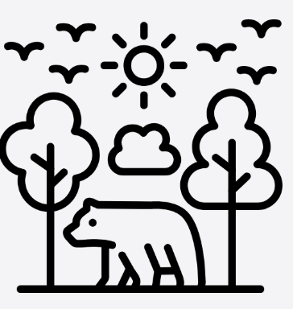 |  | Can I recognise that living things can be grouped in a variety of ways?  Can I explore & use classification keys to help group, identify & name a variety of living things in their local & wider environment?  Can I recognise that environments can change & that this can sometimes pose dangers to living things? | Can I describe the differences in the life cycles of a mammal, an amphibian, an insect & a bird?  Can I describe the life processes and reproduction in some plants & animals? | Can I describe how living things are classified into broad groups according to common observable characteristics & based on similarities & differences, including micro-organisms, plants & animals?  Can I give reasons for classifying plants & animals based on specific characteristics?
BIOLOGY | Evolution & inheritance  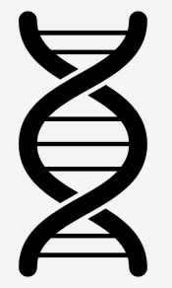 |  |  |  | Can I recognise that living things have changed over time & that fossils provide information about living things that inhabited the Earth millions of years ago?  Can I recognise that living things produce offspring of the same kind, but normally offspring vary & are not identical to their parents?  Can I identify how animals & plants are adapted to suit their environment in different ways & that adaptation may lead to evolution?
CHEMISTRY | Properties and Changes of Materials   |  | Can I compare & group materials together, according to whether they are solids, liquids or gases?  Can I observe that some materials change state when they are heated or cooled, & measure or research the temperature at which this happens in degrees Celsius?  Can I identify the part played by evaporation & condensation in the water cycle & associate the rate of evaporation with temperature? | Can I compare & group together everyday materials on the basis of their properties, including their hardness, solubility, transparency, conductivity (electrical & thermal), & response to magnets?  Can I know that some materials will dissolve in liquid to form a solution, & describe how to recover a substance from a solution?  Can I use knowledge of solids, liquids & gases to decide how mixtures might be separated, including through filtering, sieving & evaporating?  Can I give reasons, based on evidence from comparative & fair tests, for the particular uses of everyday materials, including metals, wood & plastic  Can I demonstrate that dissolving, mixing & changes of state are reversible changes?  Can I explain that some changes result in the formation of new materials, & that this kind of change is not usually reversible, including changes associated with burning & the action of acid on bicarbonate of soda?
CHEMISTRY | Rocks   | Can I compare & group together different kinds of rocks on the basis of their appearance & simple physical properties?  Can I describe in simple terms how fossils are formed when things that have lived are trapped within rock?  Can I recognise that soils are made from rocks & organic matter?
PHYSICS | Earth & space   |  |  | Can I describe the movement of the Earth, & other planets, relative to the Sun in the solar system  describe the movement of the Moon relative to the Earth?  Can I describe the Sun, Earth & Moon as approximate spherical bodies  Can I use the idea of the Earth’s rotation to explain day & night & the apparent movement of the sun across the sky?
PHYSICS | Light   | Can I recognise that they need light in order to see things & that dark is the absence of light?  Can I notice that light is reflected from surfaces?  Can I recognise that light from the sun can be dangerous & that there are ways to protect their eyes?  Can I recognise that shadows are formed when the light from a light source is blocked by a solid object?  Can I find patterns in the way that the size of shadows change? |  |  | Can I recognise that light appears to travel in straight lines?  Can I use the idea that light travels in straight lines to explain that objects are seen because they give out or reflect light into the eye?  Can I explain that we see things because light travels from light sources to our eyes or from light sources to objects & then to our eyes?  Can I use the idea that light travels in straight lines to explain why shadows have the same shape as the objects that cast them?
PHYSICS | Sound   |  | Can I identify how sounds are made, associating some of them with something vibrating?  Can I recognise that vibrations from sounds travel through a medium to the ear?  Can I find patterns between the pitch of a sound and the strength of the vibrations that produced it?  Can I recognise that sounds get fainter as the distance from the sound increases?
PHYSICS | Forces & magnets   | Can I compare how things move on different surfaces?  Can I notice that some forces need contact between objects, but magnetic forces can act at a distance?  Can I observe how magnets attract or repel each other & attract some materials & not others?  Can I compare & group together a variety of everyday materials on the basis of whether that are attracted to a magnet, & identify some magnetic materials  describe magnets as having two poles?  Can I predict whether two magnets will attract or repel each other, depending on which poles are facing? |  | Can I explain that unsupported objects fall towards the Earth because of the force of gravity acting between the earth & the falling object?  Can I identify the effects of air resistance, water resistance & friction, that act between moving surfaces?  Can I recognise that some mechanism, including levers, pulleys & gears, allow a smaller force to have a greater effect?
PHYSICS | Electricity   |  | Can I identify common appliances that run on electricity?  Can I construct a simple series electrical circuit, identifying & naming its basic parts, including cells, wires, bulbs, switches & buzzers?  Can I identify whether or not a lamp will light in a simple series circuit, based on whether or not the lamp is part of a complete loop with a battery?  Can I recognise that a switch opens & closes a circuit & associate this with whether or not a lamp lights in a simple series circuit?  Can I recognise some common conductors & insulators, & associate metals with being good conductors? |  | Can I associate the brightness of a lamp or the volume of a buzzer with the number & voltage of cells used in the circuit?  Can I compare & give reasons for variations in how components function, including the brightness of bulbs, the loudness of buzzers & the on/off position of switches?  Can I use recognised symbols when representing a simple circuit in a diagram?

