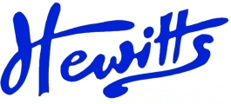
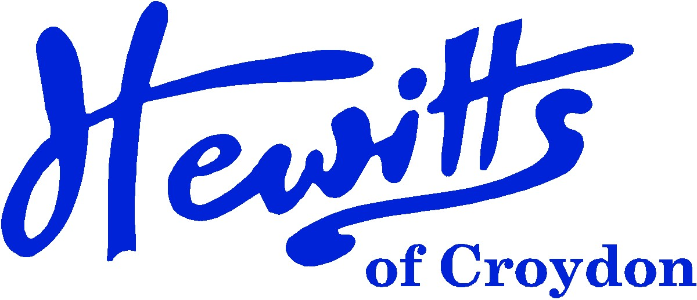

THE SMARTER CHOICE SINCE 1863

SCHOOL & SPORTSWEAR SPECIALISTS

Proud suppliers of
PARK HILL JUNIOR SCHOOL

SCHOOL UNIFORM PRICE GUIDE 2024
BOYS |  |  | GIRLS
Pullover, Grey/Blue Stripe + logo | from | 21.00 | Pullover, Grey/Blue Stripe + logo | from | 21.00
or Cardigan, Grey/Blue Stripe + logo | from | 22.00 | or Cardigan, Grey/Blue Stripe + logo | from | 22.00
Tie, Park Hill 14” Clip On | . . . . | 5.00 | Tie, Park Hill 14” Clip On | . . . . | 5.00
Shirt, Blue 2pk | from | 16.00 | Blouse, Blue BTN 2pk | from | 16.00
Trousers, Grey or Charcoal | from | 13.00 | Skirt, Grey | from | 8.50
 |  |  | or Tunic, Grey | from | 17.50
 |  |  | or Trousers, Grey | . . . . | 16.00
Socks, Black or Charcoal Ankle 5pk | from | 5.75 | Socks, Black or Charcoal Ankle 5pk | from | 5.75
 |  |  | or Tights, Grey or Charcoal | from | 7.50
 |  |  | Hair Accessories, Navy | from | 2.50
Ski Hat, Navy (Opt) | . . . . | 4.50 | Ski Hat, Navy (Opt) | . . . . | 4.50
Gloves, Navy (Opt) | from | 3.25 | Gloves, Navy (Opt) | from | 3.25
Scarf, Navy (Opt) | . . . . | 6.25 | Scarf, Navy (Opt) | . . . . | 6.25
Shoes, Black (not trainers) | from | 15.00 | Shoes, Black (not boots) | from | 15.00
SUMMER ALTERNATIVES |  |  | SUMMER ALTERNATIVES
Shorts, Grey (Opt) | from | 11.00 | Summer Dress, Blue & White (Opt) | . . . . | 16.50
 |  |  | Socks, White 5pk (Opt) | from | 5.75
GIRLS SHOULD NOT WEAR A PULLOVER WITH THE SUMMER DRESS
SPORTS/PE |  |  | SPORTS/PE
T-shirt, Sky + text | from | 5.50 | T-shirt, Sky + text | from | 5.50
PE Shorts, Navy DL17 (Indoor) | from | 6.50 | PE Shorts, Navy DL17 (Indoor) | from | 6.50
Plimsolls, Black (Indoor) | from | 5.00 | Plimsolls, Black (Indoor) | from | 5.00
Sweatshirt, Navy + text (Outdoor) | from | 12.00 | Sweatshirt, Navy + text (Outdoor) | from | 12.00
Jog Trousers, Navy (Outdoor) | from | 11.00 | Jog Trousers, Navy (Outdoor) | from | 11.00
Trainers, any (Outdoor) | from | 20.00 | Trainers, any (Outdoor) | from | 20.00
Swim Hip Racer, Navy or Black | from | 16.00 | Swimsuit, Navy or Black | from | 17.50
Swim Cap, Royal + text | . . . . | 6.50 | Swim Cap, Royal + text | . . . . | 6.50
PE/Swim Bag, Navy + text | . . . . | 7.00 | PE/Swim Bag, Navy + text | . . . . | 7.00
SCHOOL WILL INFORM PARENT/CHILD WHEN IT IS THEIR TURN FOR SWIMMING, NOT NEEDED FOR WHEN THEY START.

CLICK & COLLECT | WWW.HEWITTSOFCROYDON.COM | COURIER DELIVERY
NAME TAPES | SCHOOLWEAR | SPORTSWEAR | WORKWEAR | SCOUTS & GUIDES
We only accept cash or Mastercard, Visa and Visa Debit
All prices stated are accurate at the time of printing. Whilst we endeavour to maintain our prices throughout the season, we cannot guarantee against price changes.
Hewitts of Croydon, 45 – 51 Church Street, Croydon, CR9 1QQ
T: 0208 688 1830 / 0208 680 4555 E: customercare@hewittsofcroydon.com W: www.hewittsofcroydon.com
This price list was last updated on 17/02/2020

Hewitts of Croydon, 45 – 51 Church Street, Croydon, CR9 1QQ
T: 0208 688 1830 / 0208 680 4555 E: customercare@hewittsofcroydon.com W: www.hewittsofcroydon.com
This price list was accurate on 20/04/2024

